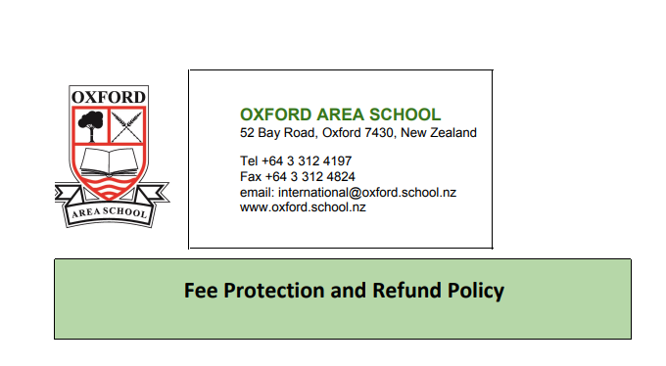

Fee Protection and Refund Policy
Fee protection
Fees paid by international students are secure and protected against the possibility of an interruption to the course. Internal procedures assist the school in monitoring income and expenditure to ensure that money is controlled appropriately.
Our fee protection policy is provided to parents before a contract is signed, and is included in the contract signed upon enrolment.
Fees received in advance should only be recognised as income earned by the school as each term commences. A portion of advance fees is transferred to the school's main bank account in instalments. Remaining fees paid in advance are available to be refunded if necessary.
Fee refund
Our fee refund policy is provided to parents before a contract is signed, and is included in the contract signed upon enrolment.
If a student withdraws from their course of study before the completion date, they may be eligible for a refund of tuition fees. The school will always investigate requests for a refund and act fairly.
- The school will consider refunding all or part of fees if:
  - there are special circumstances and proof is supplied (e.g. the child has a serious illness or accident, or the family needs to return home because of a family member's death)
  - the child gains permanent residency during the course (documentation of the residency must be provided within 14 days of it being granted)
  - the school is closed for a period of one week or more due to force majeure (defined as an event beyond the reasonable control of the school, such as snow, earthquake, etc.).
- The school is not obliged to refund fees if the child:
  - has been asked to leave the school because of poor attendance or a breach of enrolment conditions
  - wishes to transfer to another educational institution for any reason
  - has special needs that were not explained to the school on the enrolment form.
Our refund policy includes refund conditions for the following situations:
- failure by a student to obtain a study visa
- voluntary withdrawal by a student
- the school ceasing to provide the agreed educational programme
- the school ceasing to be a signatory to the Code of Practice
- the school ceasing to be a provider.
If the school ceases to provide the agreed educational programme or ceases to be a signatory to the Code of Practice, Oxford Area School will deal with the fees paid for services not delivered or the unused portion of fees by:
- refunding the amount in question to the student (or the student's parent or legal guardian)
- transferring the amount to another signatory as agreed with the student (as specified in the Code).
How to apply for a full or partial refund of fees
To apply for a full or partial refund of fees, a parent (legal guardian) must apply in writing to the principal within one month of the student's last day at school (or within one month of the student gaining permanent residency) explaining the special circumstances.
Also see Absence, Withdrawal, and Termination.
- If a parent applies for a refund before the course starts, the school will refund the fees in full, less an administration fee. If they apply for a refund after the course starts, the school determines the level of refund, taking into account costs already incurred, and an administration fee. Special circumstances are taken into consideration (e.g. death of a close family member, serious illness, accident).
Payment of refunds
The school only refunds fees directly to a parent or to an agent with written authority from a parent. The school will never refund fees directly to the student.
Immigration New Zealand is notified if any student ceases to attend Oxford Area School for whatever reason.
Also see International Student Fees.

